Human Resource Management

Week 1

Employee= Worker/staff member

SHRM: Strategic Human Resource Management (discussed in video)

**Husky**

Productivity: Measure of efficiency ‘how productive you are when completing a task’

Performance: How well something is performed (measure)

Human Capital: Person attributes and ability for achieving goals

Employee engagement: Approach in the workplace to motivate employees to perform their best, be committed to the organisation and its goals and motivation to contribute via wellbeing.

Management planning process

Strategtic planning

Overall company plan for how it will ensure the internal company strengths and weaknesses align to the external opportunities and threats.

Why: Maintaining competitive position and advantage.

Step 1: Establish ‘where are we?’

Step 2: Establish ‘where do we want to be’ (evaluating internal strengths and weaknesses to external opportunities and threats)

Steps 3-7: Plan ‘how will we get there’: Developing a business direction, strategic goal setting, decide on a strategy to ‘action’, implement and evaluate the strategic plan.

人事管理，亦称人力资源管理，是国家或某一部门为实现一定的目标，对所属工作人员进行选拔、使用、培养、考核、奖惩等一系列的管理活动。人事管理旨在通过科学的方法，正确的用人原则及合理的管理制度，调整人与人、人与事、人与组织的关系，以充分利用人力资源。

人力资源管理，（Human Resource Management，简称HRM），人事管理的升级，是指在经济学与人本思想指导下，通过招聘、甄选、培训、报酬等管理形式对组织内外相关人力资源进行有效运用，满足组织当前及未来发展的需要，保证组织目标实现与成员发展的最大化的一系列活动的总称。它是预测组织人力资源需求并作出人力需求计划、招聘选择人员并进行有效组织、考核绩效支付报酬并进行有效激励、结合组织与个人需要进行有效开发以便实现最优组织绩效的全过程。也是公司一个重要的职位。

学术界一般把人力资源管理分八大模块或者六大模块：1、人力资源规划；2、招聘与配置；3、培训与开发；4、绩效管理；5、薪酬福利管理；6、劳动关系管理。诠释人力资源管理六大模块核心思想所在，帮助企业主掌握员工管理及人力资源管理的本质。

Human resource management (HRM or HR) is the strategic approach to the effective and efficient management of people in a company or organization such that they help their business gain a competitive advantage. It is designed to maximize employee performance in service of an employer's strategic objectives. Human resource management is primarily concerned with the management of people within organizations, focusing on policies and systems. HR departments are responsible for overseeing employee-benefits design, employee recruitment, training and development, performance appraisal, and reward management, such as managing pay and Employee benefits benefit systems. HR also concerns itself with organizational change and industrial relations, or the balancing of organizational practices with requirements arising from collective bargaining and governmental laws.

trategic human resource management is the process of linking the human resource function with the strategic objectives of the organization to improve performance. Attracting and keeping talented and skilled employees is one of the most important challenges organizations face in today’s dynamic business world.

* HRM: Administrative in nature
* SHRM: Aligning with the ‘bigger picture’ of the company

Corporate:

Concentration: Offering one product/product line in one market

Diversification: Expanding by new product lines

Vertical integration: Expands by selling products directly/making own raw materials, etc.

Consolidation: Reduce size of company

Expansion: Enters new market territories, geographically

Strategic human resource management

Supporting and aligning with the vision, strategies, long-term goals and objectives of the company via a strategic framework

Aligning with other departmental goals

The connection between managing people and the company’s overall strategic vision via HR policies

More alignment + more strategic = value added

Strategic Planning and HR strategy

SHRM

To help transfer the company strategic goals to HRM policies and practices, managers can use several tools.

Tools include (but not limited to):

Strategy maps

HR Scorecard

Digital Dashboard

Strategy map

Visual ‘map’ representation of how each departments performance impacts the achievement of the company’s strategic goals

Helps to summarise and present to managers and employees the role their department plays in the contribution to the strategic plan by visually linking their efforts to the wider department achievements and finally to the ‘wider picture’.

Building the strategy map













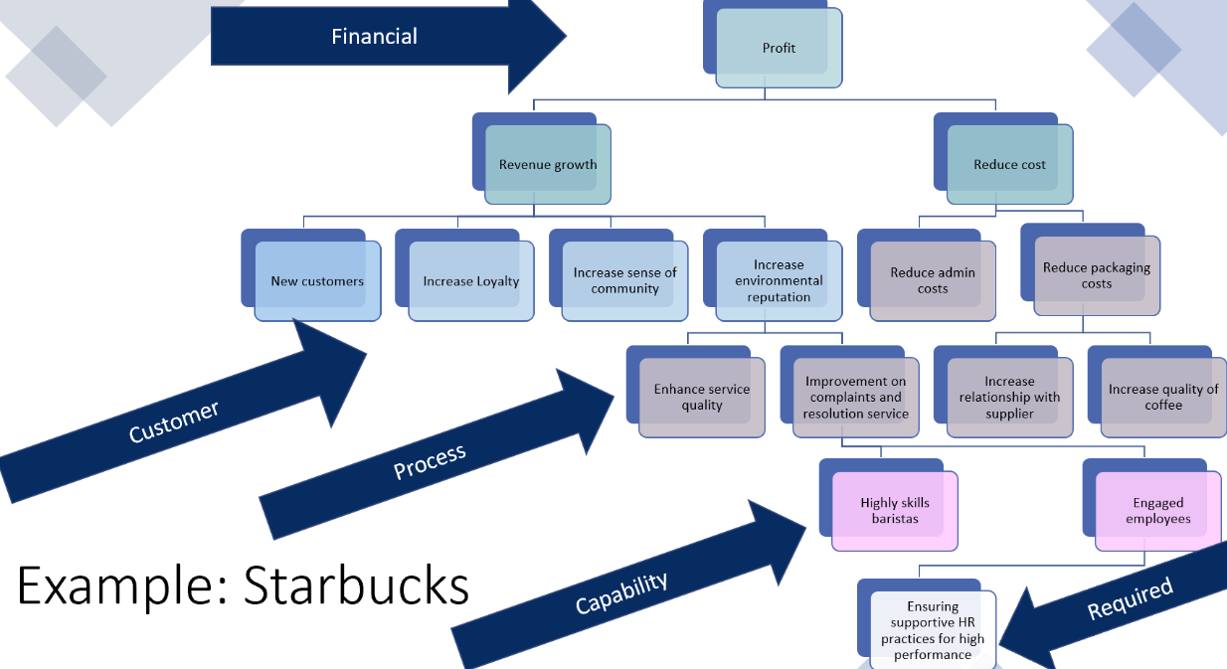

HR Scorecard

Strategy map often quantified via computer through a scorecard

Process of assigning financial and nonfinancial goals/metric to HRM related strategy map activities needed for meeting company goals

Quantifying strategy map

Can help to see (quantifiably) the relationship between HR activities, employee behavior (as a result) and strategic outcomes/performance

Dashboards

Presents graphs and charts to managers to show how the company is performing based on the scorecard.

Could display trends, real-time data, etc.

Helps for corrective action

WEEK 2

Resourcing and Talent Management

Resourcing and talent management: Critical for business

Incorporates aspects of HRM such as HR planning decisions, job descriptions, person specifications, recruitment and selection

Performance: Improved based on employment decisions and employee fit

Stages of Recruitment and talent management

Decide on the positions to fill

Build a pool of applicants

Obtain application forms

Use selection tools to identify viable candidates

Decide who to give an offer to

Orient, train and develop the employees

Appraise to see how they are doing

Compensate

Talent management

People who are valuable to company

Attract retain

Identify deploy alignnig with goals and strategic objective

Develop

engage

Job analysis

Identifying the duties of the job and the human requirements needed for each job in the company

Then, decide which jobs you need to fill and to recruit and select employees for

Information gained:

Work activities: Information about the job activities (how, why and when it is performed)

Human behaviour: What behaviours are needed for the job

Machines, tools, equipment and work aids: What tools, materials, knowledge and services used

Performance standards: Standards for performance (quality levels)

Job context: Work schedule, incentive, etc.

Human requirements: Knowledge, skill, attributes

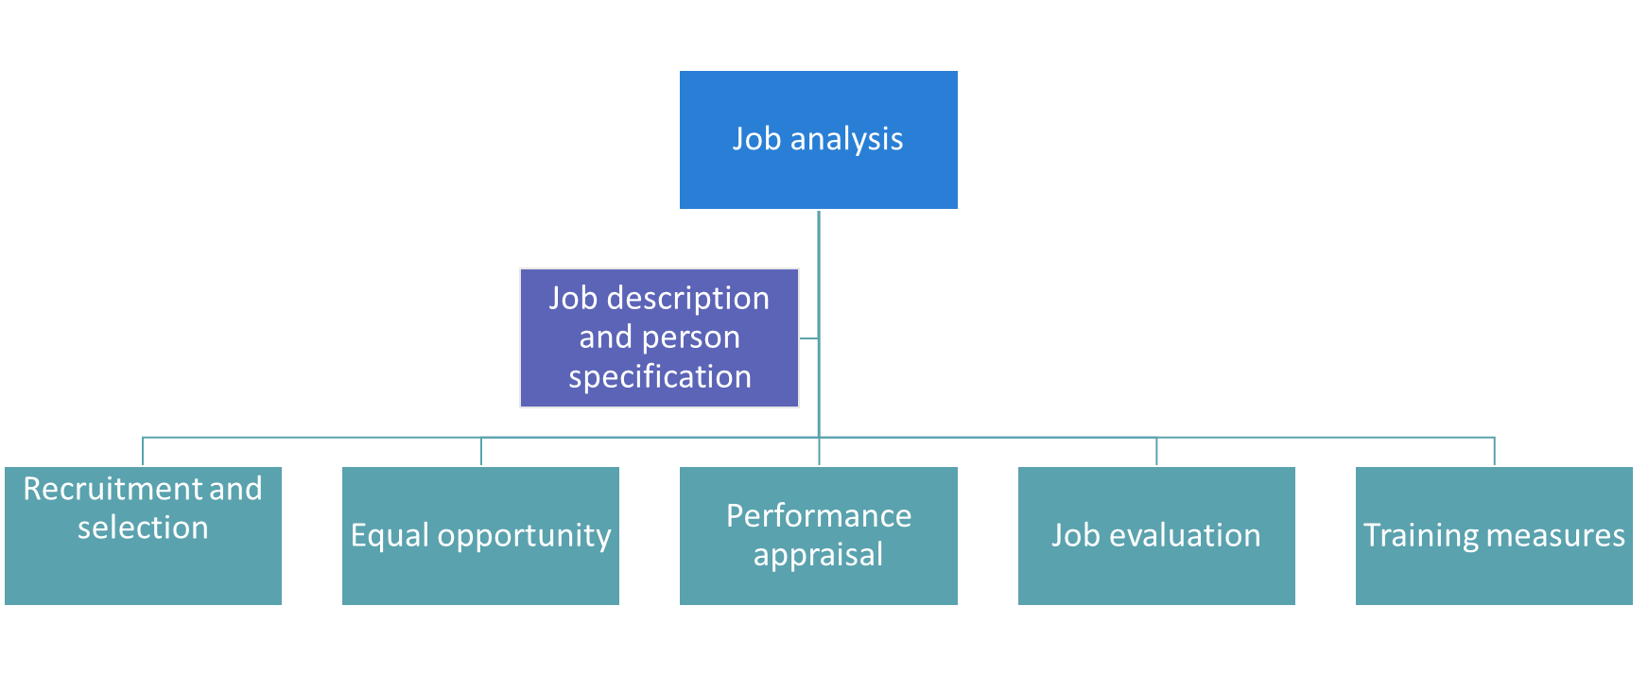

Stages of a job analysis

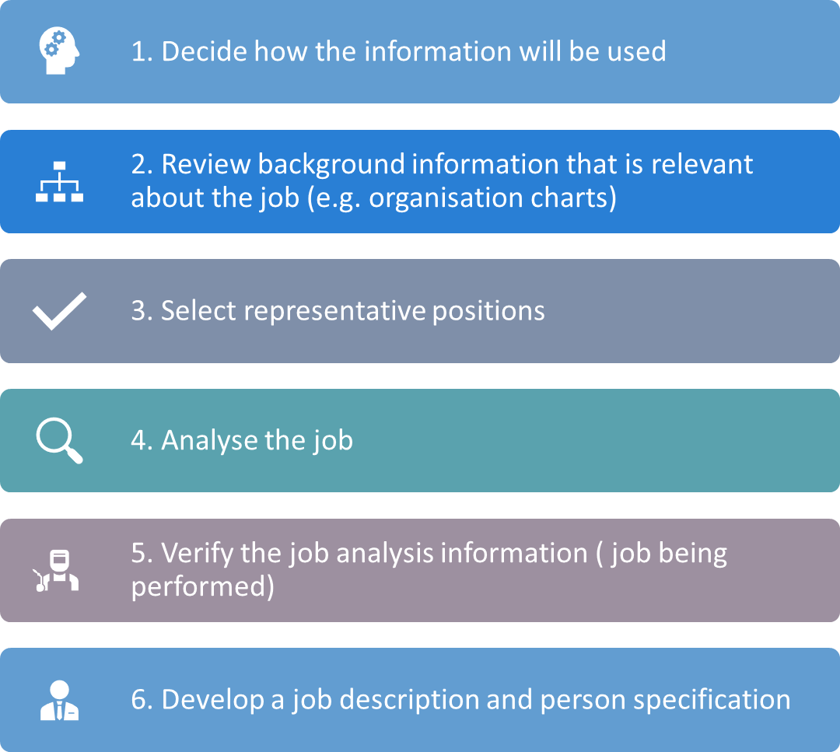

Reviewing background information relevant to the job

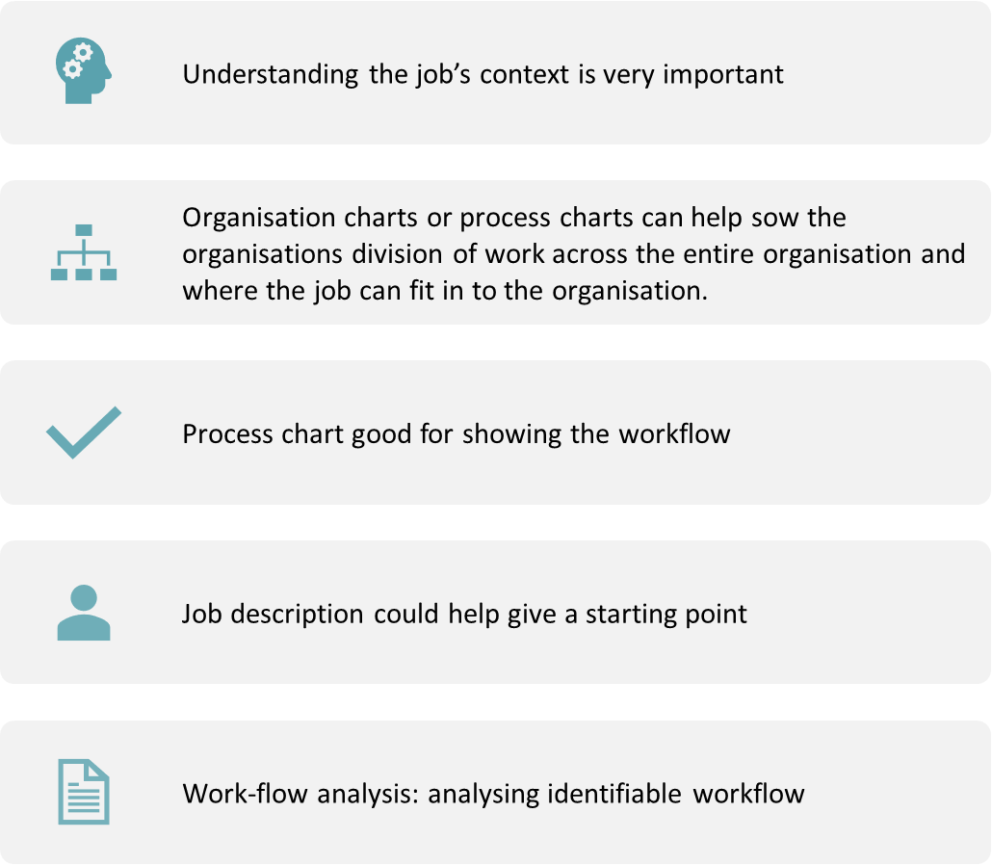

Other processes

Business process reengineering: Redesigning business processes so that steps that were needed to be taken across several departments can now be done by one team and technology

Job Design: Redesign jobs with job enlargement, job rotation, job enrichment

Selecting representative positions

Selecting a sample of positions to focus on for the analysis.

Example: Sales representative.

Unnecessary to analyse all sales representative jobs. Sample of 10 instead

Identifying specific duties and tasks for the job by approaching the job holder, explaining the process and conducting methods to collect data (e.g. interviewing)

Summary of job, jobs areas of responsibility, duties and tasks

Verifying the job

Getting an employee to perform the job with supervisor.

Check analysis information is accurate.

Helps with acceptance

Job Description and Job specification

Outlines duties, activities, responsibilities

Job Specification: Summarises person qualities, background, traits and skills required

How to collect the data needed

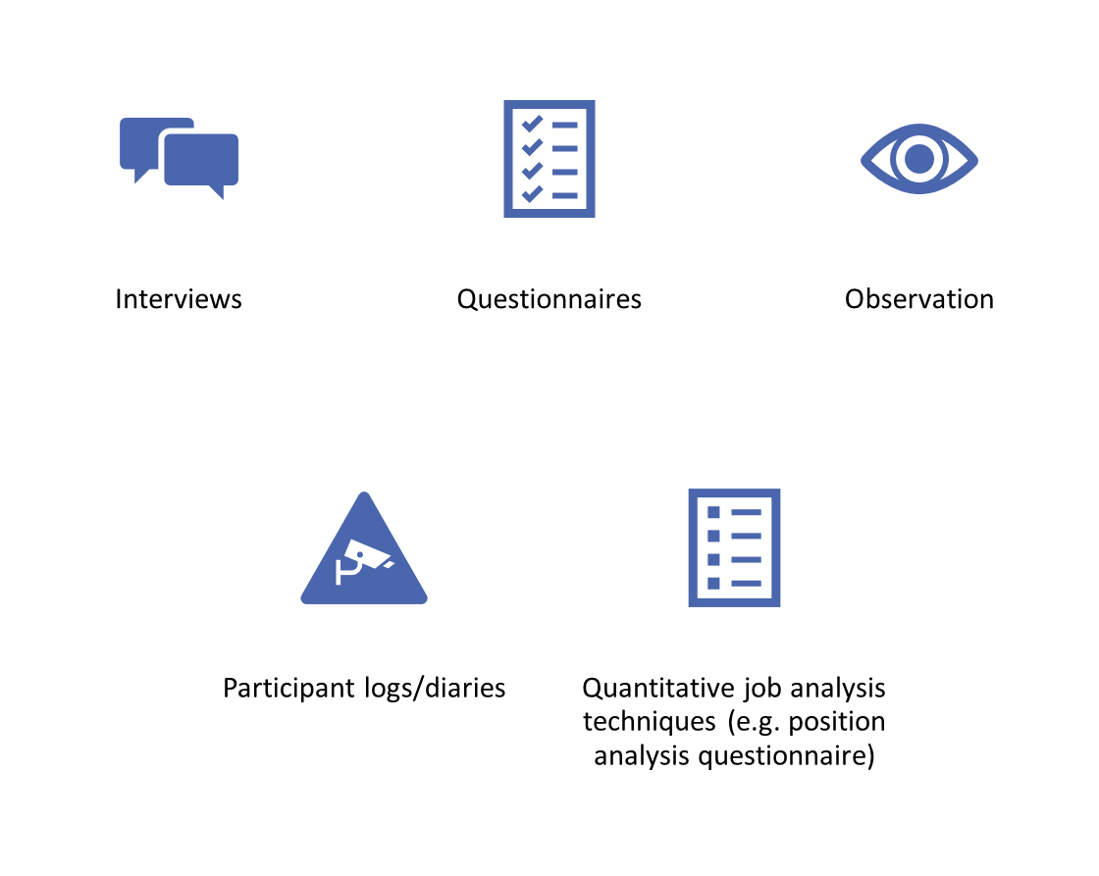

Describe

Written statement (internal) about what the employee does, how they do it, and what the working conditions are like.

Used to write job/person specification and job advertisement

No standard format.

Job identification

Job summary

Relationships

Responsibilities and duties

Authority necessary for duty

Standards of performance

Job specification

Management: HR manager-copetencies for HRM:

Planning leadship and navigation

Organizing ethical practice

Staffing business acumen-business sense

Leading consultation

Controlling critical evaluation

Global and cultural effectiveness

communication

Components of HRM:

Strategic objectives

Recruitment and selection

Integerating and maintaining employees

Training and development

Compensation and rewards

Importace of HRM

Improve profits

Improving performance

Mitigating against personnel issues and mistakes

Before：传统构成要件

Now：数字化工具（digital tools）

中层责任更大（line managers）

Future: more integrated

所有工作中

Keys trends

劳动力增加多样性

按需工作，基于角色的服务（On demand jobs ,service based on roles） and 灵活工作

全球化

信息技术化

经济压力

外包的（outsourcing）HRM

省钱

转移风险

Job design

Job anaylis

Job describe job se

Adverstiment

WEEK 3

Job specifications

* Taking the job description and looks at answering the traits and experience needed to perform the job effectively
* Qualities required (testing the applicant for these)
* Focus points: Previous experience (and length of service), quality of training, performance in previous job
* Trained vs untrained roles: Filling the specification for untrained jobs is harder- looks to identify traits that predict performance

Job specifications: Judgement vs statistical

Judgement/subjective approach: Educated guesses from HR managers

Statistical analysis: More difficult but more justifiable approach

Looks at the relationship between: Predictor (e.g. human trait like intelligence), and indicator of job effectiveness (e.g. performance)

5 step approach: Analyse, select, test, measure, statistically analyse relationship = does trait predict performance

5 step approach:

Analyse: The job and measure of job performance

Select traits that should predict performance

Test applicant for traits

Measure applicant job performance (subsequent)

Statistically analyse relationship between trait and performance

: Desirable traits for engagement

Traits to suggest and predict likelihood of engagement

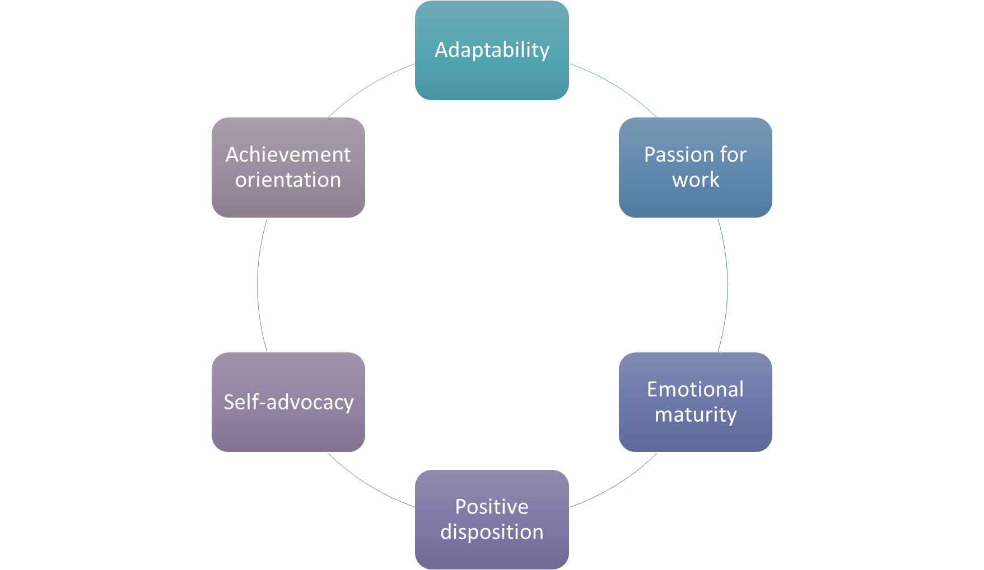

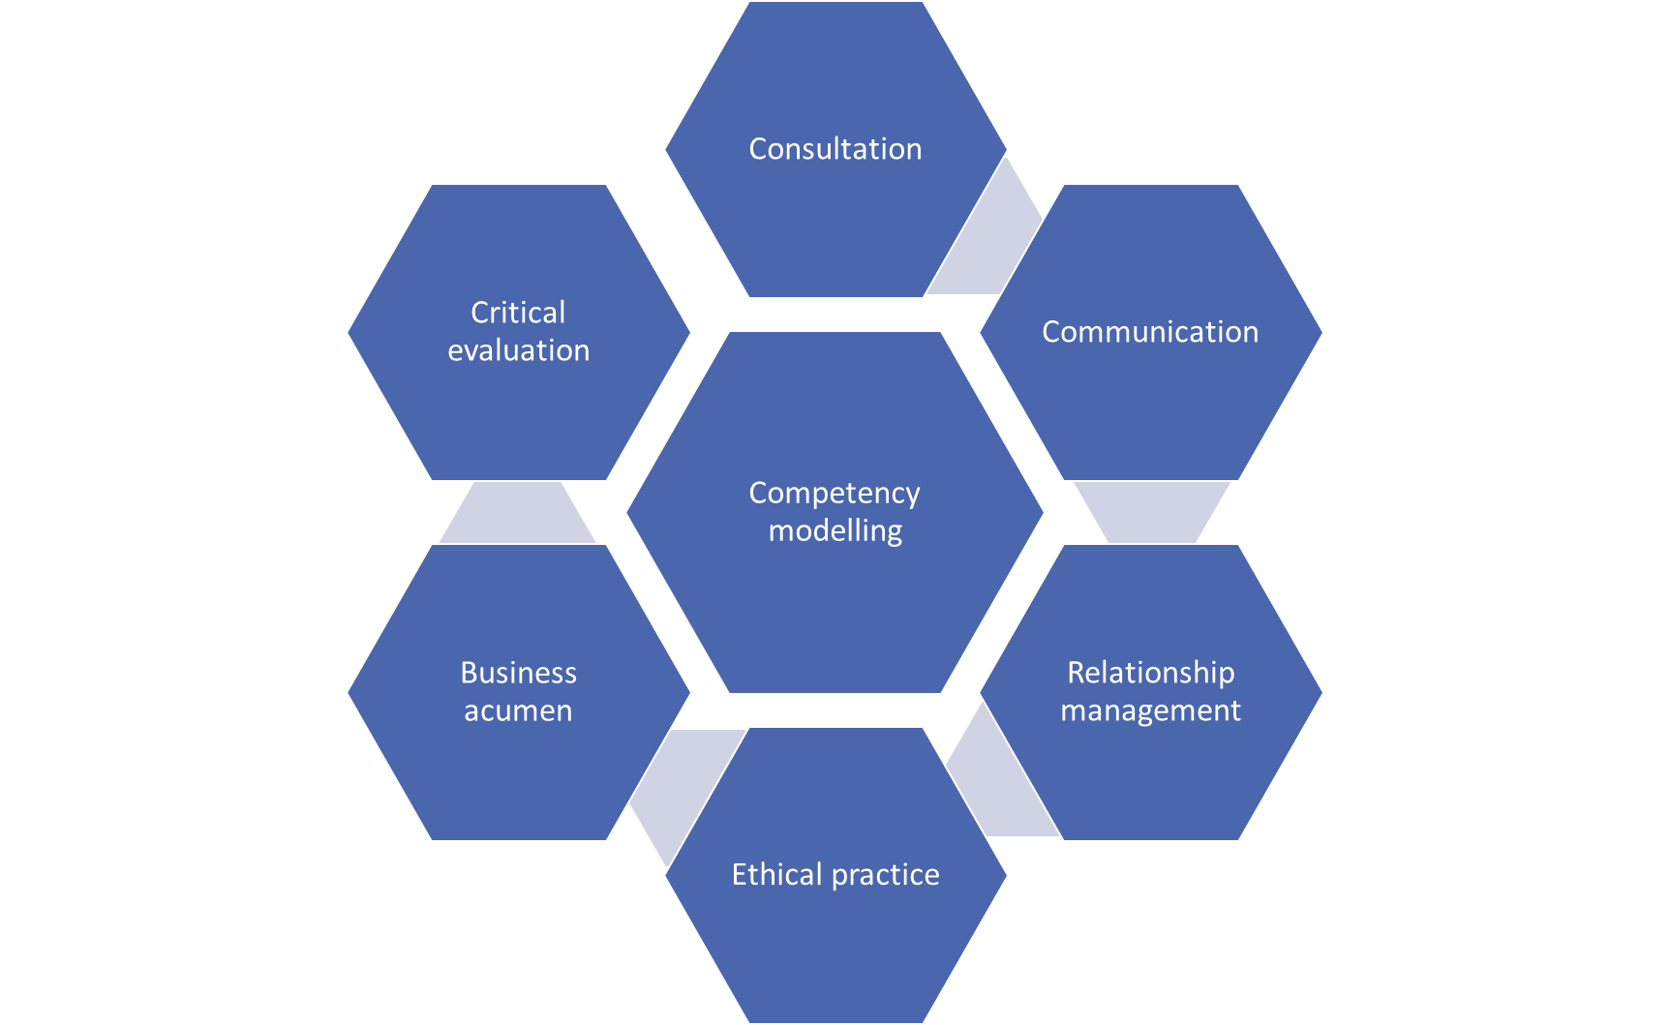

Competention

Natural: Dimensions of personality e.g. extravert, introvert, emotional stability, agreeableness, openness

Acquired: Knowledge/ skill founded via work, etc.

Adapting: Adapting natural talents and acquired skills to a new situation

Performing: observable behaviours/outputs

*1. Name and a description*of the competency: Facilities Manager: Managing and maintaining a portfolio of sites

2. Description of observable behaviors needed to represent proficiency: Continuously manage site risks and dependencies with timely decisions being made

3. Proficiency levels.

Workforce planning

Also known as employment or personnel planning

Process: Decide which position the business needs to fill and how they need to fill them

Needed before recruitment and selection takes place

Should be considered in context of wider business strategic planning

Decisions to fill positions will have impact on training, recruitment plans and other HR plans

Forecasting need

The number of people needed with a particular skill and what the skill needed is

Needs to be considered when thinking of strategic goals, turnover rate and productivity.

Estimating the demand (e.g. worker demand) based on estimated demand of products/services

Projecting personnel needs: Trend analysis, ratio analysis, scatter plot, managerial judgement

Forecasting supply

Availability of applicates (e.g. inside and outside)

Initially looking at inside applicants (possible)

Personnel Replacement chart: ‘card’ created for each position. Present performance and promotability for a potential replacement on a position and helps identify performance, promotion potential & training

Outside: Forecasting availability in industry (unemployment rates, skill gaps, etc.)

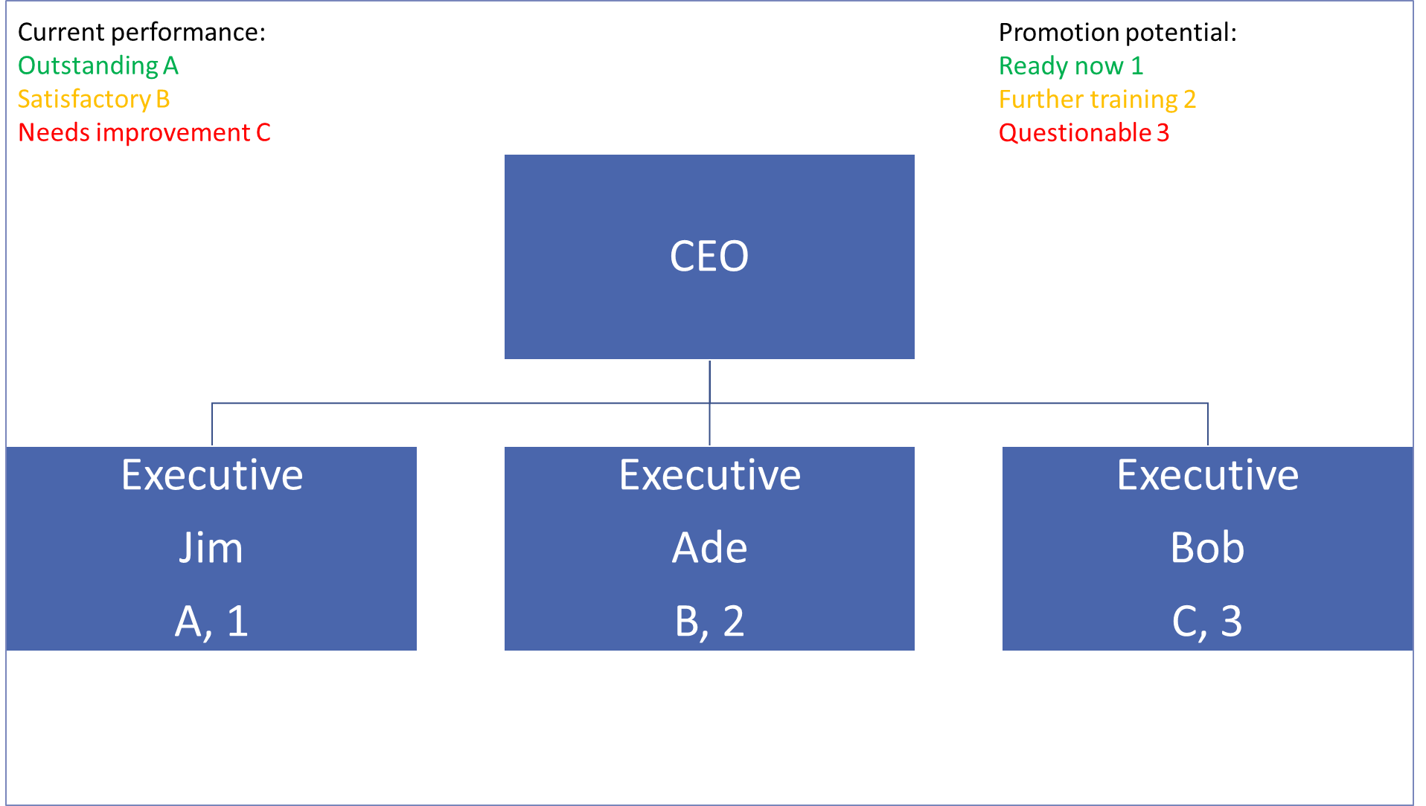

Successce planning

Ongoing process of identifying, assessing and developing organisational leadership

Developing workforce plans for the top positions at the company

Steps:

Identify key position needs

Develop inside applicants

Assess and choose who will fill positions

Recuriting: Attracting applicants for the positions to fil.

Effective recruiting measures: filling an open position with talent

Internal vs external

Internal: Hiring from within organisation – often best source

Finding internal: Job posting via bulletin boards, company intranets

Promotion: Assumption = higher employee engagement

Example: ME, at the University of Worcester

Recruiting methods

Diversity and inclusion, and employment law needs to be considered and complied with

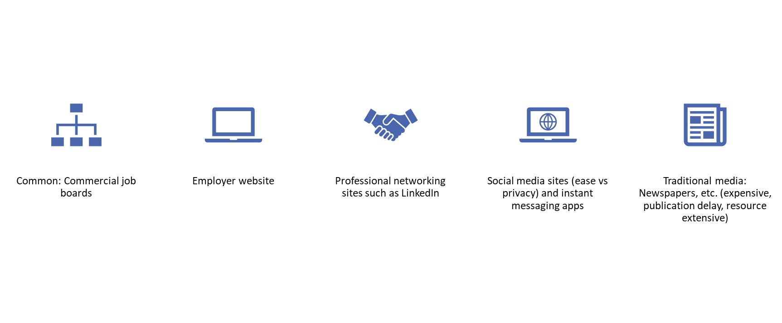

Diversity and inclusion, and employment law needs to be considered and complied with

Recruiting methods: recruiting service

Range of services: Attracting applicants, managing responses from applicants, screening and shortlisting, assessment centres for company.

Must have understanding of organisation and the requirements

Works well if needing to quickly fill an opening

Cons: quality of applicants, cost, lack of branding

Head-hunters (executive services): Seek top-management talent (e.g. executive positions)

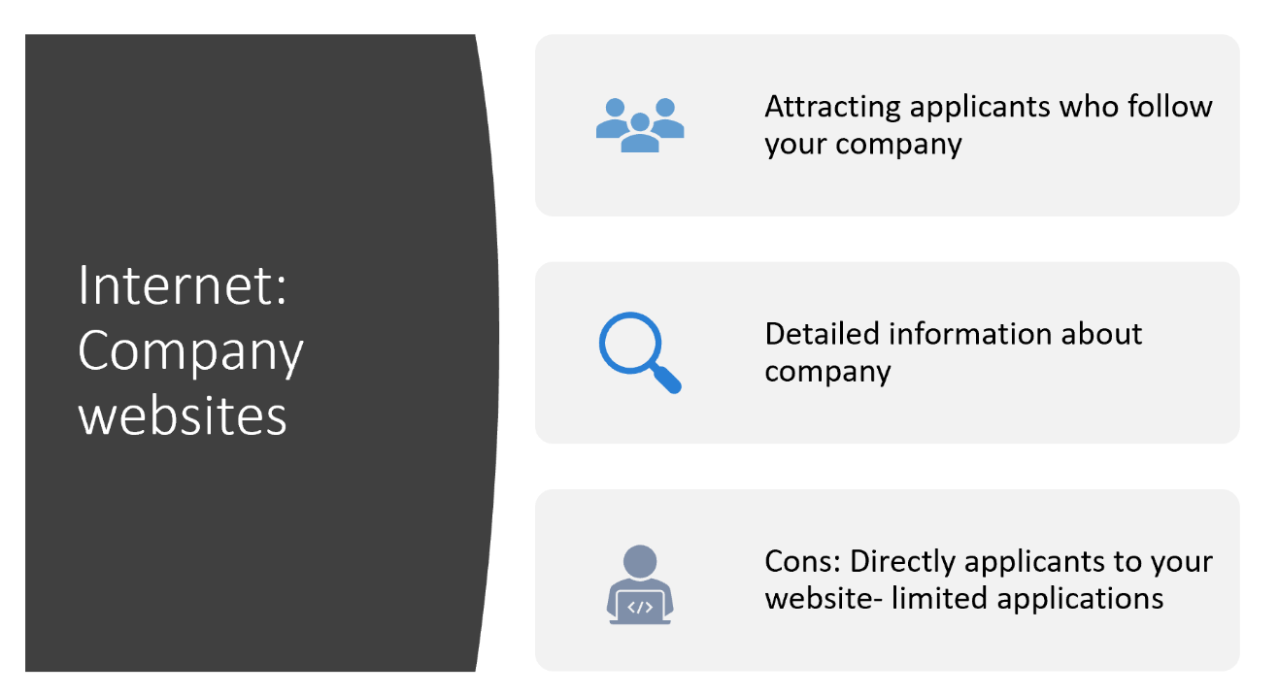

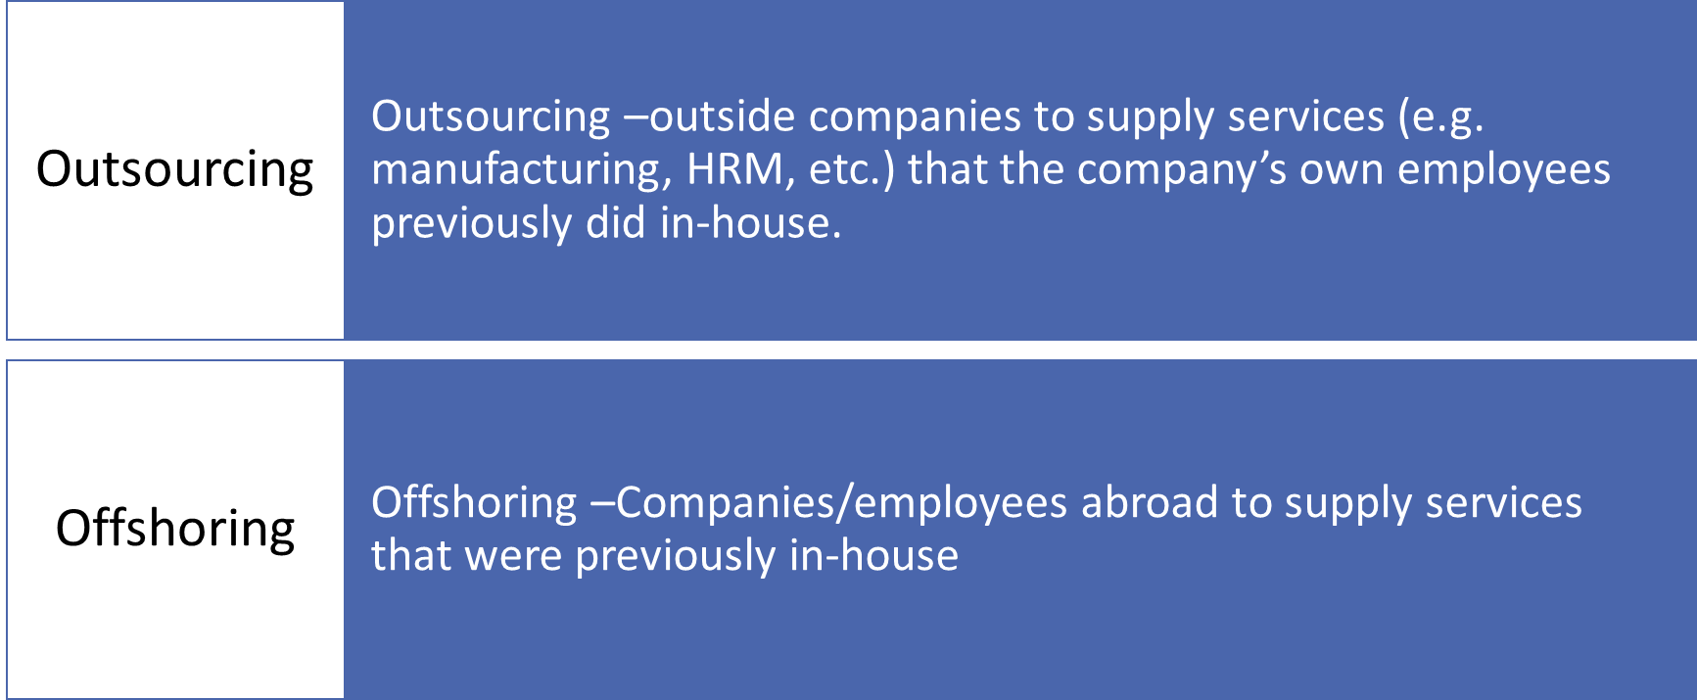

Application Job advervtisement

Common forms to apply: Applications, CVS or professional profiles

Job advertisements: Need to attract attention, interest, desire, action (AIDA)

Job advertisement needs to look appealing using marketing language.  
Example: “We are seeking a receptionist” to “we are looking for someone with a great personality and uplifting spirit to serve as the face of the company, greeting clients as they walk through the door”

Keep it short (no longer than 700 words)

Job advertisement needs

A job title that can be understood by potential applicants

Salary range and location

Headings to break up text on the page

Introduction to the job opportunity and company

Required skills

Desirable skills

Supportive and positive language to attract

Responsibilities

State how to apply and contact details

Logo of company

WEEK 4

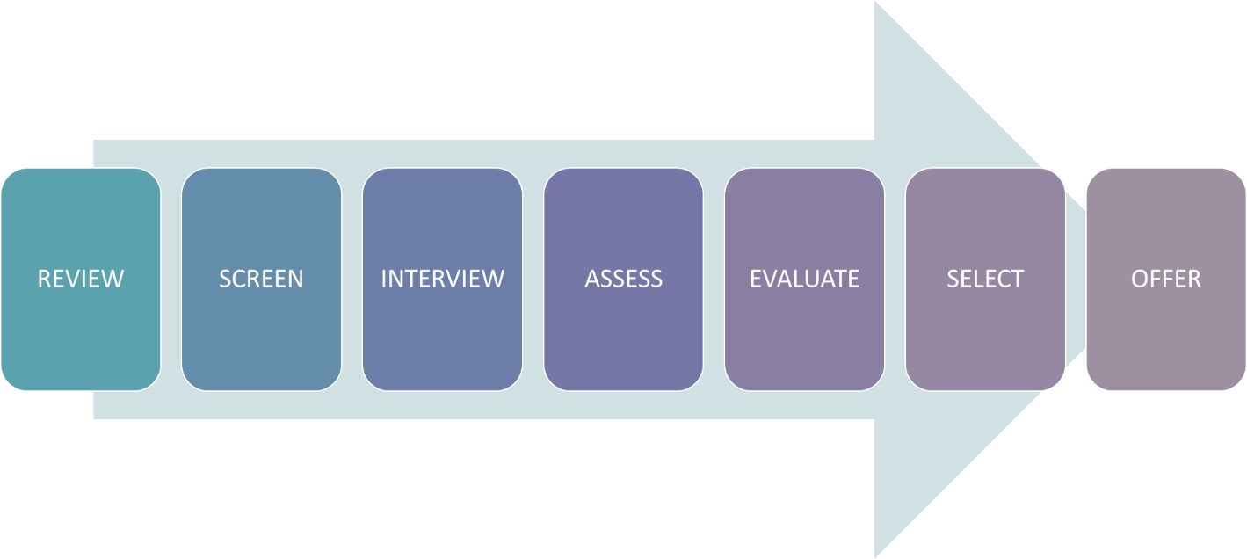

Measures in selection

Reliability: Degree of consistency and dependable

**Validity:** Relationship between what we measured and what was intended (e.g. selection device scores & eventual performance scores

Example:

High test scores = high job performance

Low test scores = low performance

Validity types: criterion, content & construct

Background investigation

Helps to verify applicant information and uncover information which could damage the company

Reference checks

Background employment

Criminal record

Driving record

Education

Medical exams

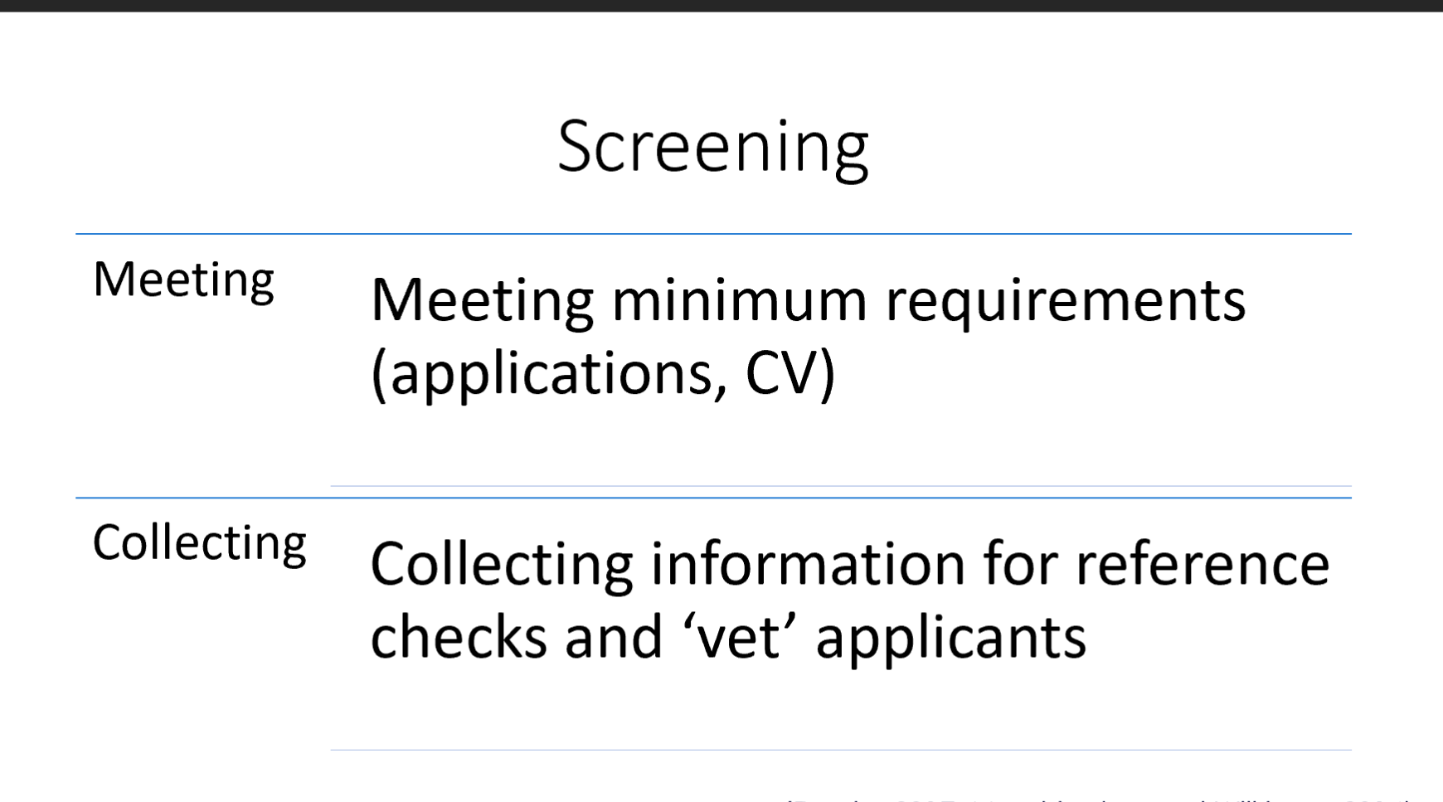

* Companies rely heavily on interviews
* Different types of interview (structured vs Unstructured)
* Need to be properly trained in interview techniques

Intervivew

|  |  |
| --- | --- |
| advantage | Disadvantage |
| * Get to know applicants more * Communication and see how applicants react * overview | * Costly * Resource intensive * Care taken with questions * Snap judgements and bias * Difficulty in predicting future performance |

Popular test

Reviewing Tests: Methods

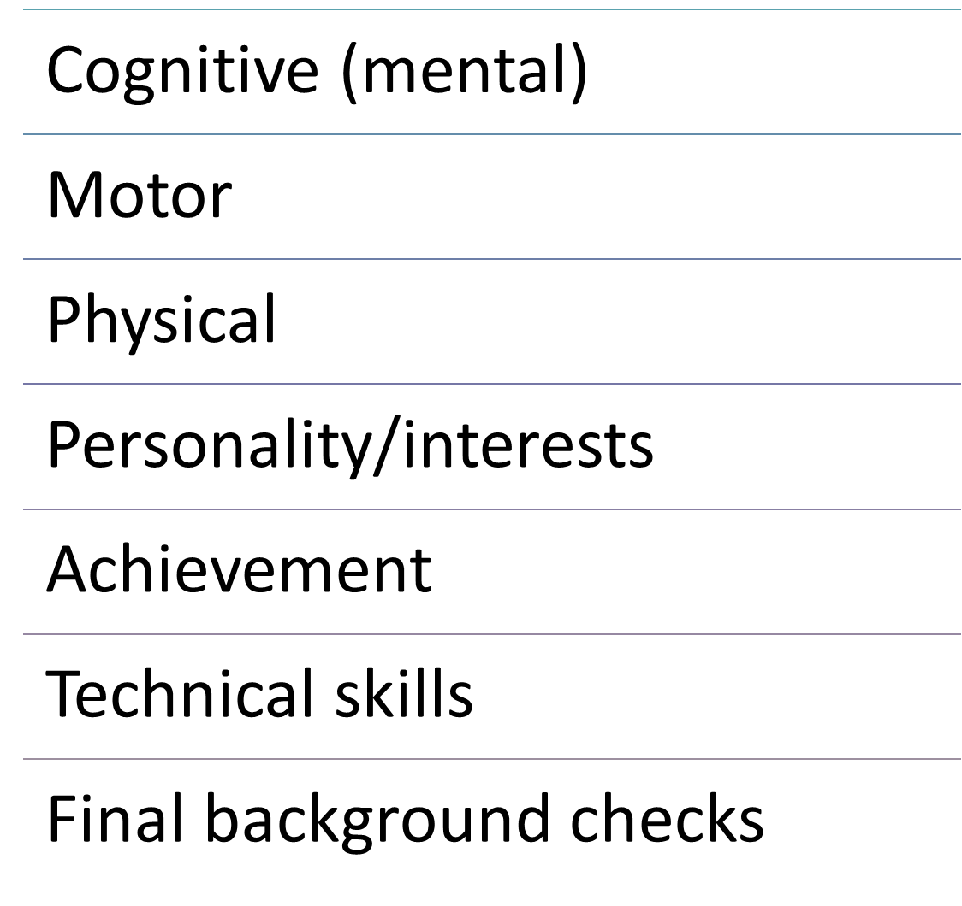

Cognitive tests

Tests for general reasoning/ intelligence and specific mental ability.

Specific tests can include:

Memory and other mental abilities

Inductive reasoning

Inductive reasoning

Start with specific information and then making generalised conclusion

Apples in basket: Ripe or not

Testing general intellectual ability

Measurement of range of abilities

Memory, verbal fluency, numerical, vocabulary

ID score: above or below average score

Measures for specific mental abilities (deductive reasoning), memory, numerical ability, verbal comprehension

Often called aptitude tests = ability to react to situations and perform tasks

General statements to specific conclusions

Example:

Apples are fruit + Fruit have seeds

Conclusion: Apples have seeds

* + Reliable
  + High validity toward job performance
  + Group setting distribution
  + Cost: Lower than personality test
  + Scoring tests = computerised
  + Diversity potential scores
  + Difference in certain abilities can impact scores between

Motor and physical test

Measuring motor or physical abilities

Example: Hiring a pilot = need to know reaction times

Measuring: Finger and manual dexterity (coordination)

Physical ability: Firefighter, police force, etc.

* Large groups tested
* Easy to administer

Motivation levels, preparedness and practice impacting scores

Must be in same test area

Achievement tests

Measurement of what you have learned

Exams = achievement tests

Measurement of job knowledge

Some tests can measure capabilities (fastest running time)

Work stampling

Asking applicants to perform some of the tasks required for the job

Predict job performance

Advantage:

Measures job task performance

Better to predict performance via validity

No issues of privacy

Disadvantage:

Does measure personality, etc.

No prior training

Miniature job train and envoluation

Train applicants to complete job tasks

Evaluate their performance

Measurement of learning and performance of tasks

Realistic job previvew

Preview the whole job before hiring

Help to decrease turnover

More likely for applicants to turn down job offers

Resource intensive

Pros and cons of tests

Pros: High validity levels, automation, less resources

Cons: Potential discrimination, test must be standard condition, applicants need to understand how it is relevant to job, tests administrators need to be trained, applicants could have been coached.

Population types of interview

Online

Telephone

Group

Individual face-to-face

Assessment centre interviews

Panel/mass

Avoiding errors

Using structured interviews

Focus on what you want to ask

Avoid snap judgements

Ensure you clarify what the job requires (pre-close)

Avoid letting personal characteristics bias your judgment

Ensure diversity and avoid discrimination

Planning the interview

Communicating acceptance AND rejection

Making the decision

Judgmental approach: Weighing all the evidence about the applicant, subjectively

Statistical approach: Uses a formula to predict job success- evidence measured quantifiably

Hybrid approach: Statistical results + judgment

Offer the job

Job offer needs to include:

Pay rates

Job duties

Benefits

Letter to applicant offering the job

Employment contract

Duration of employment

Duties

Rules about resignation and termination of contract

Nondisclosure requirements, confidentiality requirements, etc.

WEEK 5

Employee induction

Induction: The process to welcome and socialize new employees into the organization

Attempt to introduce a new employee to what it will be like working for the organization

Process for new employees to adjust to:

Their jobs

Their working environment

Also referred to as onboarding: process from contact with organisation before joining, to understanding their job

Employee Lifecycle- Induction

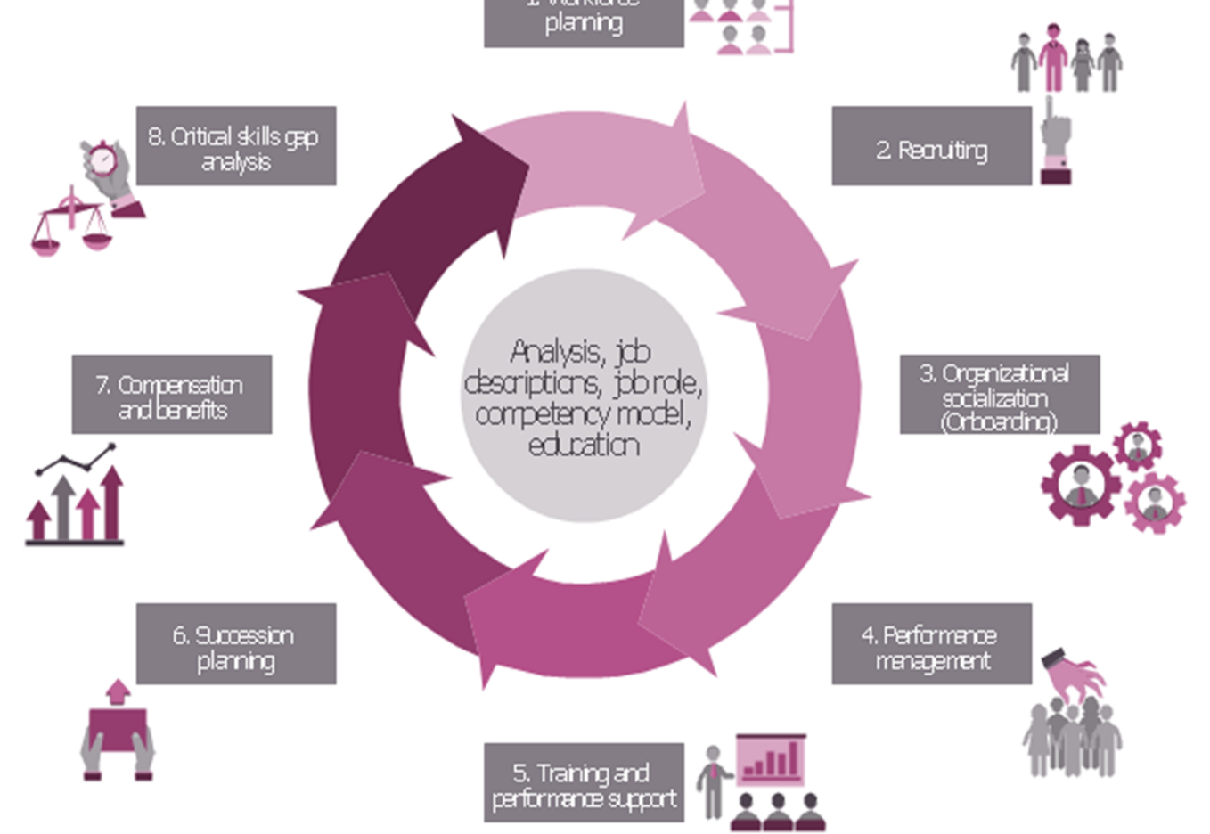

The purpose of induction

Help them to understand the organisation and its culture

Start socialising the new employee to company culture and ‘way of doing things’ = values

* Make new employees feel welcome and part of the team
* Make sure they have basic information
  + Email access
  + HR policies and benefits
  + Expectations
  + Work behaviour and conduct

Purpose

Help to increase talent retention rates and reduce staff turnover

Takes around 23 weeks to achieve best productivity in staff

Better productivity

Helps to increase motivation and employee commitment

Increase employee competence

Help to create business-specific skill.

Key element of induction:

Person job fit :Key qualities an employee needs to succeed

supported by training and development

positive outcomes when employee fits their environment

matching the right person to the right Job

Person organisation fit: Person is matched to the organisations culture

Positive = Job satisfaction, organisational commitment & Intent to

Organizational socialization : Process: Person appreciates companies values, abilities, expectation and social knowledge

socialisation =first step to fit with the business

communication of Performance, aptitude, politics and information

acceptance in the new organization.

Orientation: Specific course training/event for new starters

Socialisation: Building working relationships and finding roles within the team

Start off with socialisation process to help employees fit into their new work surrounding

Ensuring a positive first impression to give a positive lasting impact

Help to introduce new employee to organisation to see what it will be like

How dose induction help:

Helps to settle new employees

Helps to get them productive in their work

Reduced protection for ‘induction crisis’

Meeting legal requirements ( e.g. health and safety)

Confirmation that the hire was the right decision

How to do induction

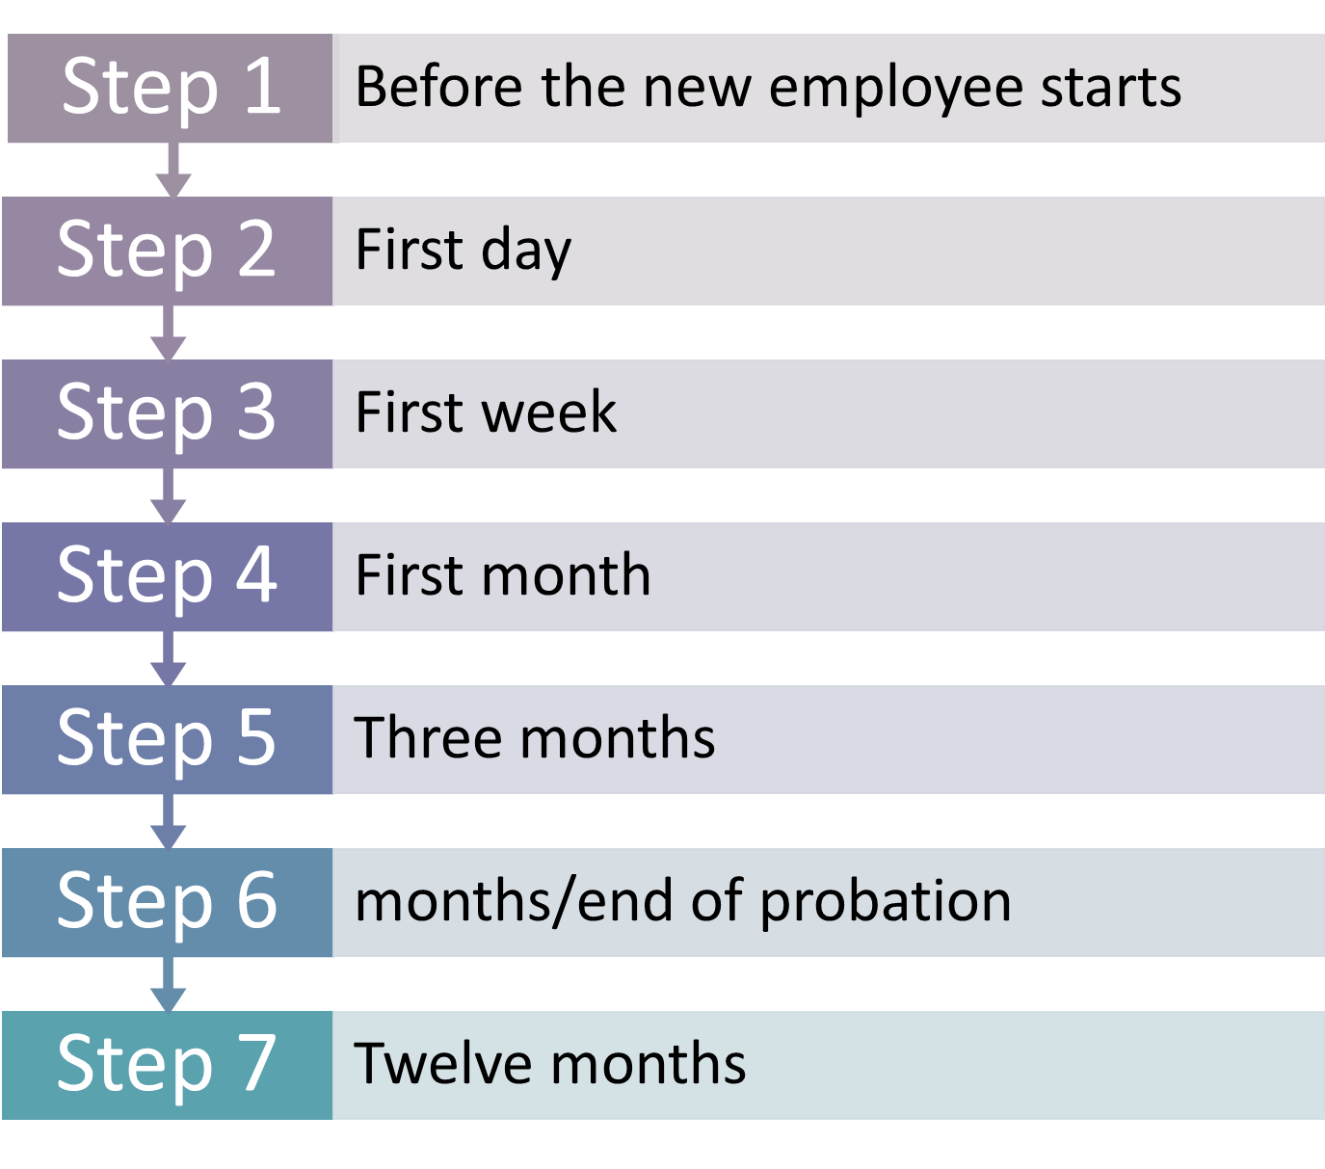

Step 1

Sending useful information to employee about the company

Planning induction (who they will meet on first day, mentor allocation, workspace allocation)

Providing a welcome pack

Decide the induction approach (formal or informal)

Induction plan (what, when, who)

Checklist for induction

Tailor program to suit employee (e.g. graduate vs experienced)

Think through explaining additional considerations ( work patterns, locations, duties, working hours, etc.)

Allocating a mentor to help with daily questions

Preparing the persons workspace (account, phone number, ID, etc.)

Ensure all policies, and practices are up to date with legislation

Step 2 : First day

Introductions

Arrange manager/supervisor/mentor meetings

Deal with documents that are important

Discuss health and safety and legislations

Tours of the office

What to avoid on one day :

Giving too much information and paperwork

Leaving a new employee alone for a long time

Throwing them in to the job

Delaying the induction

Not having an induction

Step 3 : First week

Explaining the organisation and the workers, the new employees roles and how they will fit in

Explaining how the company assess performance

Getting new employees to try basic tasks

Discuss workplace rules (policies, expected behaviour, etc.) and terms and conditions of employment

Provide anymore safety information

Give more information about operational processes (car parking, canteen facilities and dress codes)

Step 4 : First month

* See how the new employee is settling in (informally)
* Identify if further training/coaching is needed
* Establish if there are any concerns
* Giving feedback regularly
* Arrange follow-up meeting with manager/ supervisor and mentor
* Check employee performance and what can be improved
* Give further support to induction with timed goals

**Step 6: 6 months/end of probation**

* Decide if employee is going to keep job after probation or whether they need to be fairly dismissed or probations needs extending
* Review performance and set next 6 months goals
* Review performance and the effectiveness of their training/coaching
* Giving feedback
* Plan 6 months ahead for objectives
* Assess if more experience or training is needed
* Appraisal: 9-12 month end of year review
* Give correct minimum notice
* Pay outstanding wages
* Pay holiday pay (UK)
* Make sure it’s fair dismissal
* Dismissal must be lawful and in line with contract dismissal procedures

Step 7 : 12 months

* Performance management review/appraisal
* Ask for employee feedback on induction and its effectiveness

Step 8 ：Next steps

* Continuing to support and develop employees to benefit company & increase loyalty and ability

Important for new employees to feel: room for future job development opportunities, can perform their best, encouraged, recognised and rewarded

Designing the programme

* Selection of best fit employees doesn’t guarantee effective performance
* Need to know what to do and how to do it to get good performance
* This needs to be covered in induction
* HR department normally designs the orientation and training programmes for induction.
* Supervisors will carry out most of induction (orientation and training)

Inducton and onboard : manager roles

* Welcome
* Basic information
* Understanding the organization
* Socialization

**HR and L&Ds role in induction**

* To design, develop and evaluate induction policy and programmes
* First point of contact for new employees
* Ensuring important information (e.g. bank details) are collected and employee knows what to expect from induction
* May implement some bits of induction
* Ensuring program fits with employer brand

(L&D : learning and development)

Formal induction courses

* Formal induction common in large organization
* Likely to be combination of one-to-one discussions and formal group presentations

Formal induction courses :

advantage

* Groups course saves time
* Digital tools = online induction globally distributed
* Giving positive brand message (values and culture)
* Enables socialization

disadvantage

Group induction can take place after employee has joined the company

Some topics will be less relevant and appealing to some employees

Less personal

**Topics to be covered in Induction: Pre-employment**

* Joining instructions.
* Proof of the legal right to work in the country
* New starter forms
* Conditions of employment.
* Organisation literature or other media.

**Topics to be covered in Induction: Safety**

* Emergency exits. end evacuation procedures.
* First aid facilities.
* Health and safety policy.
* Accident reporting.
* Specific hazards.
* Security procedures.
* Compliance training

**Topics to be covered Facilities and IT**

* Site map - canteen, etc.
* Guided tour
* Telephone and system information.
* Security pass.
* Car park pass.
* Opening hours.

**Topics to be covered : L&D**

* Development opportunities
* Personal Development
* Career management.
* **Topics to be covered in Induction: Organisational information**
* Background.
* Organisation chart - global / departmental.
* Strategy
* Products and services.
* Systems.
* Customer care policy.

**Topics to be covered in Induction**

**Role specific information**

* Outline of requirements of job role
* Introduction to the team/ways of working.
* Meeting with key senior employees
* Organisational orientation;

Culture and Values

* Mission statement.
* Employer brand.
* Values.

**Topics to be covered: Benefits and policies**

* Pay - payment date and method.
* Tax
* Workplace / stakeholder pension schemes.
* Other benefits.
* Expenses and expense claims.
* Working time, including hours, flexi-time, and arrangements for breaks.
* Holidays, special leave.
* Probation period.
* Equality and diversity policies.
* Wellbeing strategy, including absence / sickness procedure.
* Internet, intranet, email.
* Performance management system.
* Discipline procedure.
* Grievance procedure.
* Employee resource groups.

Consideriation

Is this their first job (graduates, etc.), do they have experience or are they returning to the workplace?

First time

Induction needs to make clear:

* What is expected
* Where they fit
* Opportunities for training and development
* Understanding

Returners

* **Addressing:** 
  + Change in childcare and caring responsibilities
  + Returning to work (e.g. maternity or adoption)
  + Returning from illness or surgery (long term)
  + Career break
  + Returning from further study
  + Redundancy
  + New career change

Inducting: homeworkers

* Online induction
* Flexibility
* Commuting to induction (cost, time, etc.)

[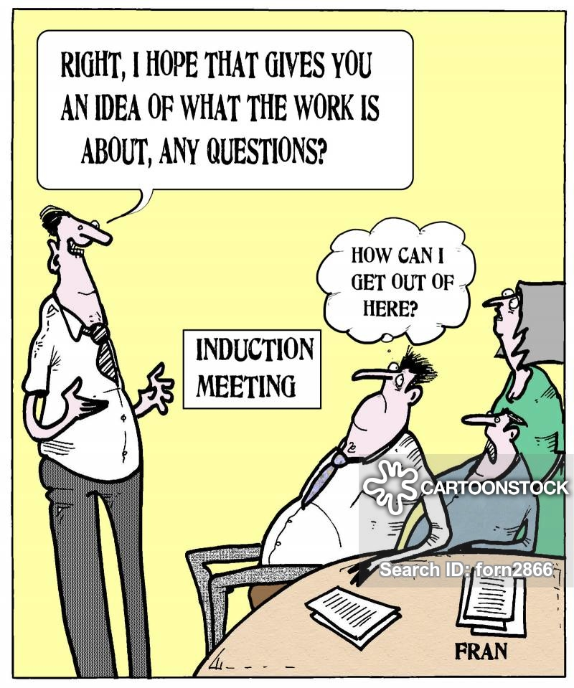](https://www.google.com/url?sa=i&url=https%3A%2F%2Fwww.cartoonstock.com%2Fdirectory%2Fi%2Finduction.asp&psig=AOvVaw2Bc3Kwo80CAxPeIBk4iqgk&ust=1602334349322000&source=images&cd=vfe&ved=0CAIQjRxqFwoTCPCiouXGp-wCFQAAAAAdAAAAABAO)

WEEK 6

Type of train needs

Knowledge

Skill

Attitude

Indicator

Output

Time

Complaint

Turnover

Level of training need

Organization

Job

Individual

Training

* Giving new/current employees skills they need to perform the job
* Training can help to produce engagement, but training can only help so much. The best person for the job is needed first!
* Training could be via current employee training new employee, or classes, etc.
* Avoiding negligent training claims

**Training: Aligning with strategy**

* Company’s strategic plans (covered in week 1) should help to form the training goals
* From the plan:
  + Identification of employee behaviours and competencies needed to fulfil strategy
  + Put training goals and programs in place to heighten competencies

Strategic changes can mean the type of skills needed changes, and training and staff policies change

**Addie: Five-step training process**

**Step 1: Analysis – conducting training needs analysis**

* Strategic training needs analysis
* Current training needs analysis
  + Task analysis
  + Performance analysis

**Strategic Training needs Analysis**

* Identifies the training that employees will need to fill future jobs.
* Looks at strategic goals
* Often looking at businesses expanding and new jobs that are needed

**Current training needs analysis**

* Training efforts = improving current performance (new employees or current performance shortage).
* Analysing current training needs depends on if they are training new or current staff
  + **New employees:** determining what the job entails and how to teach these tasks (sub tasks)
  + **Current employees:** Identify whether training is the solution

**Current training needs:   
Task vs performance analysis**

* **Task:** Identify training needs of new employees. Study of job for specific skills
* **Performance:** identify performance deficiency and training needs of current employees

**Performance analysis**

* Can’t do problem- Lack tools or skills
* Won’t do problem- Could do the job but don’t want to

**Analysis:**

* Appraisals
* Job related performance: customer satisfaction rate, productivity, absenteeism, late deliveries, etc.
* I expect Sandie to sell 10 tours per week, but she is only selling 5 per week on average

**Training needs: Indicators**

* Objective process of data collection and analysis needed to see if training solution is needed or not

Indicators

* Training = fulfilling business need, goals and outcomes
* Output: If output is b
* elow standards set, training problem?
* Varying standards between similar groups of employees
* Time: If standard times not met (e.g. unproductive time use)
* Delays in process
* Complaints: Customer complaints
* Turnover: High staff turnover
* Absenteeism: Absence from work
* **Level of training need**
* **Organisational:** Strategy and objectives, key measurements, indicators, change projects, organisational culture and climate
* **Job:** Training for tasks and responsibilities needed for job role or group of jobs (skills, knowledge, attitudes)
* **Individual:** Performance vs measurement standards. All individuals should meet against standard-if not, then training is needed.

**Considerations and problems**

* Outdated needs analysis
* Identifying the wrong need
* Ensuring reliability and validity in the data collected for training need

Designing the training program

* Planning overall training program:
  + Training objectives, delivery method, program evaluation
  + Setting objectives, creating training outline (start to finish), choosing delivery, verifying program with management

**Training design framework**

* **Step 1**: Understand the nature of learning needs
* **Step 2**: Identify purpose and objectives
* **Step 3**: Identify human factors (strengths and weaknesses, type of learner, etc.)
* **Step 4**: Identify costs and resources
* **Step 5:** Organisational context and structure
* **Step 6**: Learning principles and learning transfer

**Design: Considerations**

* Setting learning objectives​
* Creating a motivational learning environment
* Make the Learning Meaningful
* Making skills transfer obvious and easy
* Reinforce learning

**Setting learning objectives**

* Should address performance deficiencies identified in needs analysis
* Learning objectives must be practical
* Must take in to account training costs and budget and time constraints
* **Creating a motivational working environment**
* Training program should think about ability and motivation
* **Ability:** What the trainee needs (required reading, writing, maths skills, etc.)
* **Motivation:** Support for the training, positive reinforcement, value of completing training is high, capacity to do the training is there

Make the learning meaningful

* Learners will be more motivated to learn if it has meaning for them.
* At the start of training, you should:
  + Provide outline of material and how they are important
  + Use examples that are familiar
  + Logically organise information
  + Use familiar words and phrases
  + Use visual aid (images, graphs, etc.)
  + Create a pre-training need

Make skills transfer easy

* Similarity between the training and the work
* Practice must be adequate
* Identify each step in process/machine
* Attention- Direct attention to important parts
* Give information about future occurrences ‘heads up’

Learning at own pace

Reinforce learning

* The training needs to be reinforced, before, during and after training
  + **Before:** training inputting in to the training program, attendance policy, participation
  + **During:** give training experiences that mirror work environment
  + **After:** Appraising and rewarding new skills

Developing the training program

* Collect training content and materials​
* Identify training Methods​
* Identify type of training
* Implement program
* Evaluate effectiveness of program
* Type of training method:
  + Training centred: controlled by trainer
  + Learning Centred: led by the learner
  + Coaching: trainer-learner partnership
* Off-the-job: Purely for learning rather than achieving tasks
* Internal or external delivery
* Might be delivered as part of a course
* Trainer centred
* Types: Lectures, discussions, case studies, role plays, e-learning, etc.

Integrated

* Combine learning with performance of tasks/activities within the workplace
* Leaner-centred
* These are classed as ‘learning options’ rather than ‘training options’
* Types: On-the-job, coaching, shadowing, mentoring, job rotation, etc.

Evaluating the program

* Combine learning with performance of tasks/activities within the workplace
* Leaner-centred
* These are classed as ‘learning options’ rather than ‘training options’
* Types: On-the-job, coaching, shadowing, mentoring, job rotation, etc.

Evaluating,,,effectiveness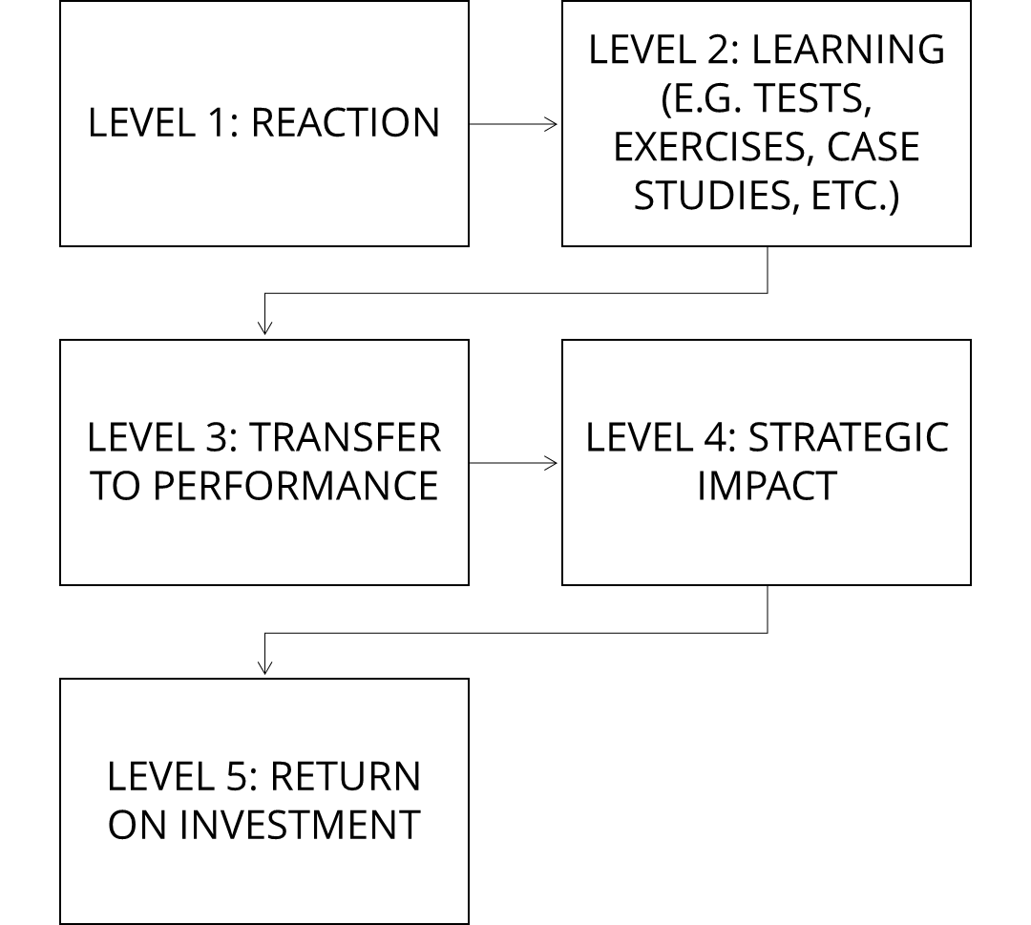

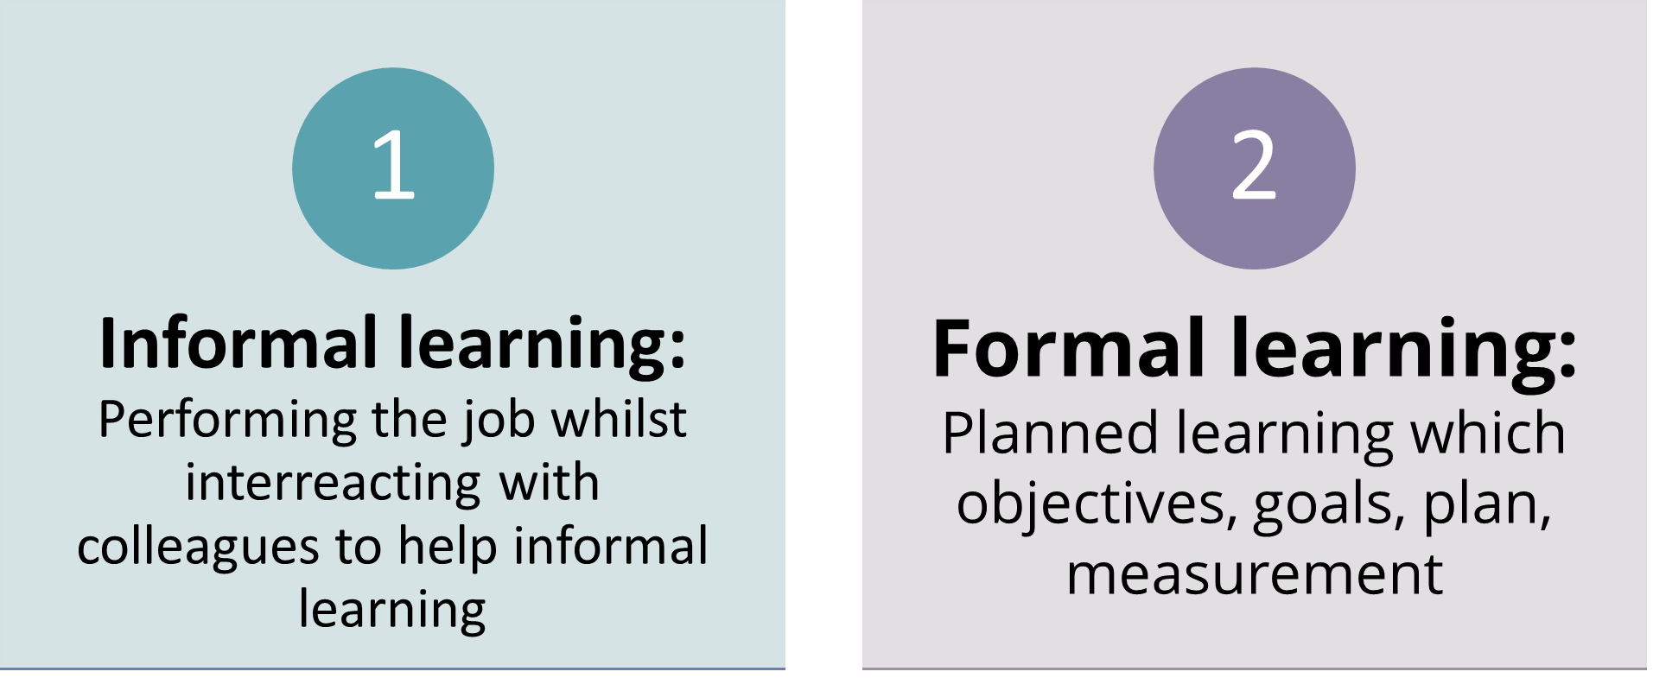

Types of training: Integrated/on the job

* **On-the-job training. Examples:**
  + Coaching
  + Job rotation
  + Exercise/project
  + **Off-the-job training. Examples:**
  + Seminars
  + Case studies
  + Role playing

**Employee/trainee/learner**

* Employee who is going to be trained:
  + Trainee
  + Learner
  + Person who is going to train the employee:
    - Teacher
    - Trainer
    - Provider (external company)

**Types of training: Integrated/on the job**

* **On-the-job:** Learn by doing the job
* **Coaching:** meeting coach on 1-1 basis to work on work-related issues
* **Mentoring:** mentor supports trainee for personal development and help to point trainee in right direction
* **Exercise/project/special assignment**: Working on projects/problems
* **Job rotation**: Moving from job to job in company (usually management trainee)
* **Shadowing:** observing experienced practitioners at work
* **Action learning**: working in groups to address business problem. Question, solve, reflect
* **Secondment:** spending time (3-12 months) in different job or responsibilities to normal- new knowledge and skills

**Apprenticeship training**

* Structured process: People become skills workers via classroom instruction (formal learning) + on-the-job training
* Trainer/supervisor: Master at the job

Team training

* Focusing on technical, management and interpersonal skills
* Encouraging team of employees to learn with and from one another

**Behaviour modelling**

* Shows trainees the right way to do something
* Let’s trainees practice
* Giving feedback on performance of trainee

Procedure

* **Modelling:** Live or video examples to watch (right way)
* **Role-playing:** simulated situations to practice what they have learned
* **Social reinforcement:** Praise and feedback
* **Transfer training:** Applying skills in their jobs

Programmed learning

* Step-by-step method for teaching skills for the job
* Self-learning method (text book, internet, iPad, etc.)
* **Parts:**
* Presenting questions/facts/problems to learner
* Allowing learner to respond
* Providing feedback on answers (e.g. accuracy) and next-step instructions

Off the job

* **Lecture:** Presenting information to trainees via structured talk
* **Case studies:** Trainees have written descriptions of scenario/ problems to find and solve
* **Role playing:** Realistic situation to handle with trainees having different roles to solve
* **Discussion:** free exchange of information to discuss topic in brief
* **Business game/simulation:** using manual or computer games or virtual reality, trainees manage scenarios based on information and options in game.
* **E-learning:** delivered via internet or internal intranet
* **Job skill instruction:** skills taught by explanation, demonstration and practice (e.g. how to operate pc program). Step-by-step

**Blended approach**

* Using both integrated and off-the-job, internal and external training methods to create the training programs for employees (new and established employees)

**Technology impacting training**

* **Internet based training:** Online courses (in-house of external training provider)
* **Learning portals/ Learning Management systems (LMS):** Section on company website that has online access to training courses
* **Virtual classrooms with collaboration:** Live audio, discussions, communication, visuals and PowerPoints
* **Mobile learning** : Courses optimised for mobile devices
* **Web 2.0 learning** : Using social networks, virtual worlds, and synchronous and asynchronous delivery systems

**Management development programs**

* Attempting to improve managerial performance via providing new knowledge, changing attitudes and increasing skills
* Types of development programs: In-houses courses, coaching, rotational assignments OR external professional programmes, seminars and conferences

On the job

* **Action learning:** programs allow managers to analyse and solve problems in other departments (e.g. real-world problems beyond usual expertise and experience)
* **Job rotation:** Moving managers from department to another department to broaden abilities
* **Coaching:** Works with senior manager

Management: Off-the-job

* Case studies
* Management games/simulations
* Outside seminars
* University programs

Role-playing

* Management games/simulations
* External seminars/conferences
* University programs

Evaluating the program

* To address the effectiveness of a training effort:
  + Evaluation study (e.g. Evaluation form_
  + Controlled experiment
  + Outcome measurement (reaction, learning, behaviour, results)

**Training effects to measure**

1. **Reaction**: Did they like the program?
2. **Learning:** Determine whether they learned skills, facts, principles as expected
3. **Behavior:** Has their on-the-job behavior changed because of the training?
4. **Results:** Did the results of the training achieve training objectives